**Documentation for Corner Grocer item-tracker program**

Program goals:

Read input file of listed items sold from Corner Grocer. Program should read input, count the frequency of each item, print item and frequency in a new data file.

Program should print a menu, allowing users to select from 4 options as follows:

1. Search for one item or word and have the frequency returned
2. Search for 3 different items or words and have the frequency of each returned
3. Search for 3 different items or words and have a histogram of frequency returned
4. Exit program

Functionality is appropriate, see below:

Screenshot of exit function and creation of “frequency.dat” file.

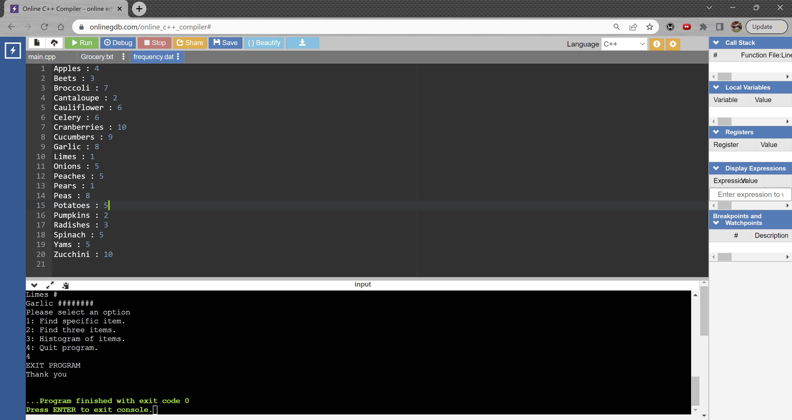

Code may be improved upon in the future with the addition of input validations and the use of functions for improved readability.